ROBBOTECH SALES SYSTEM

Submitted by:
Manahil Fatimah 2025(S)-CS-94
Supervised by:
Sir laeeq Khan Niazi

Department of Computer Science
University of engineering and Technology
Lahore Pakistan

Abstract:
This Console-Based Robot Selling System is a sleek, user-friendly platform designed to streamline robot commerce. It features dual roles—Owner and Customer—with simple authentication for secure access.
Owners can effortlessly manage robot inventory by adding, viewing, and organizing stock.
Customers enjoy a smooth browsing experience, exploring and purchasing robots with ease.
Every transaction is automatically recorded, ensuring accurate and transparent sales tracking.
The system eliminates manual record-keeping, reducing errors and saving time.
With a clean console interface and logical flow, it combines simplicity with functionality.
It's ideal for small tech shops or academic use where speed and clarity matter.
This project showcases fundamental programming principles with practical utility.
Future enhancements could include payment gateways or GUI integration.

Description

The Robot Selling System is a console-based application built to simulate a basic tech marketplace.It supports two user roles—Owner and Customer—each with tailored functionalities.Owners can add new robots to the system and monitor existing stock levels.Customers can explore available robots and make purchases seamlessly.
Each action is logged automatically, ensuring a reliable transaction history.
The system uses basic role-based authentication for access control.
It offers an efficient, text-based solution for managing and selling robotic products.
User Application:
ROLES | CAPABILITIES
Owner | Add robots,view stock,see sales history.
customer | Browse robots,make purchase.

Functional requirements:
1. Authentication:
- Login as Owner/Customer
2. Owner Features:
- Add new robots to inventory
- View all available robots
- Check current stock levels
- View customer purchase history
Owners can add new robots to the inventory and keep track of current stock levels with ease.
They can view a complete list of all available robots in the system at any time.
The system provides real-time updates to ensure accurate inventory management.
Additionally, owners can access detailed records of customer purchase history for reference.

3. Customer Features:
- View robot catalog
- Purchase robots
- Check stock availability
Customers can browse the full robot catalog to explore available options.
They can select and purchase robots directly through the system’s interface.
Before purchasing, customers can check the availability of each robot model.
This ensures a smooth and informed buying experience within the platform.

Wireframes:
Login:
Code:
while (true) {
string id = who();
Output:
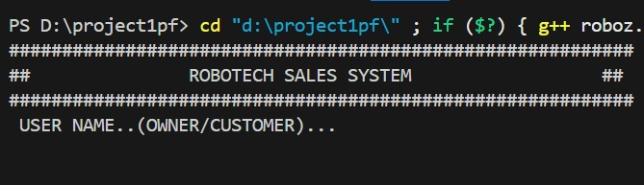
Code:
while (true) {
string id = who();
if (id == "OWNER") {
while (true) {
ownerMenu();
int owneroption;
cin >> owneroption;
clearScreen();
if (owneroption == 1) {
addRobot();
else if (owneroption
viewRobots();
}
else if (owneroption == 3) {
checkStock();
}
else if (owneroption == 4) {
viewCustomerRecords();
}
else if (owneroption == 5) {
cout << "Exiting system. Goodbye!" << endl;
break;
}
else {
cout << "Invalid choice. Please try again." << endl;
}
clearScreen();
Outputs:
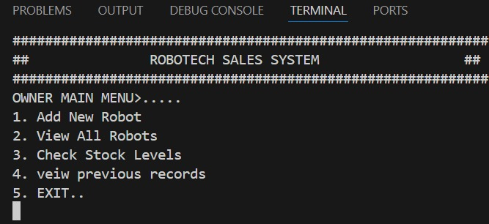
Code:
if (id == "CUSTOMER") {
while (true) {
customer
int customeropt;
cin >> customeropt;
clearScreen();
if (customeropt == 1) {
viewRobots();
}
else if (customeropt == 2) {
buyRobot();
}
else if (customeropt == 3) {
checkStock();
}
else if (customeropt == 4) {
viewCustomerRecords();
}

else if (customeropt == 5) {
cout << "Exiting system. Goodbye!" << endl;
break;
}
else {
cout << "Invalid choice. Please try again." << endl;
}
clearScreen();
}
}
clearScreen();
return 0;
Outputs:
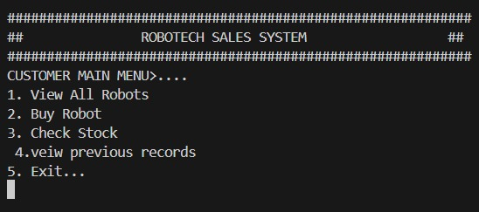

Prototypes of Functions:
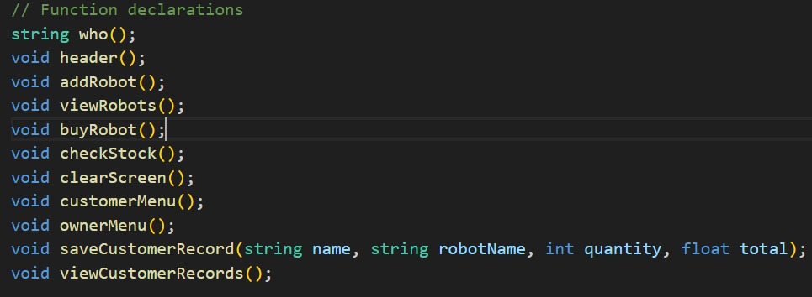

Function Definitions:
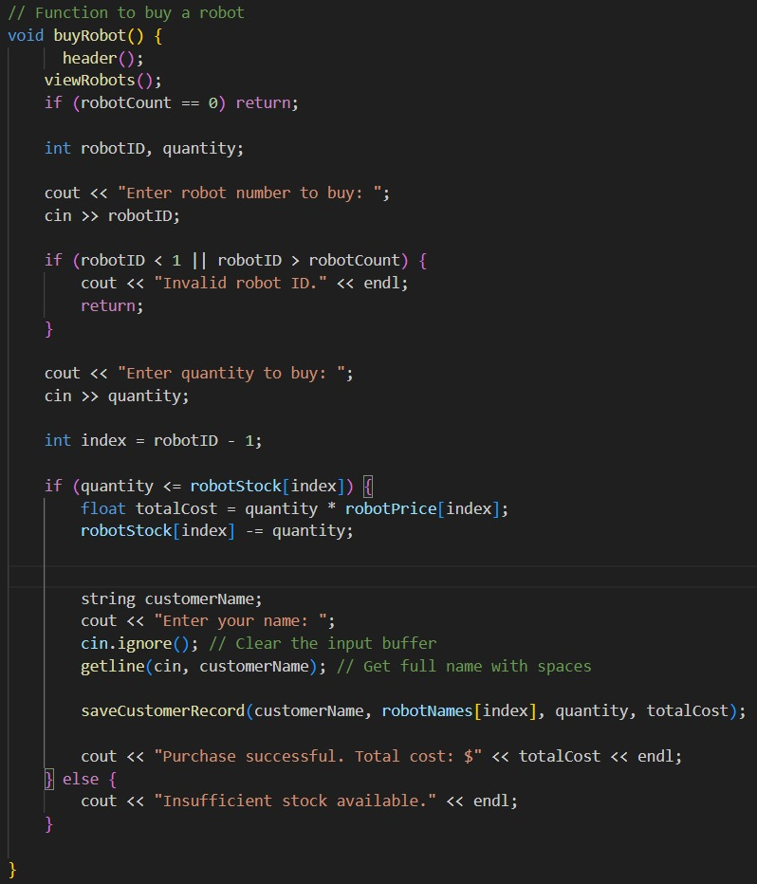
Outputs:
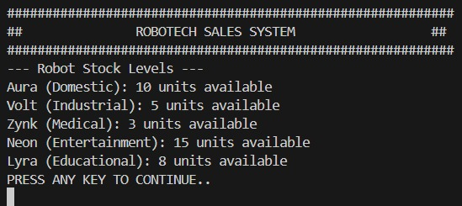

Function Definition:
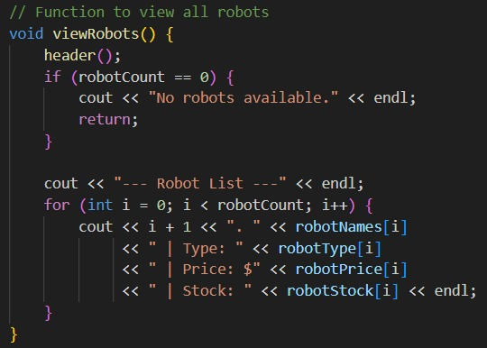
Outputs:

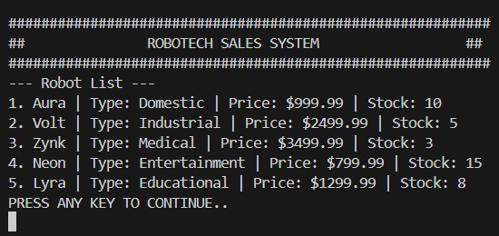

Function Definition:
: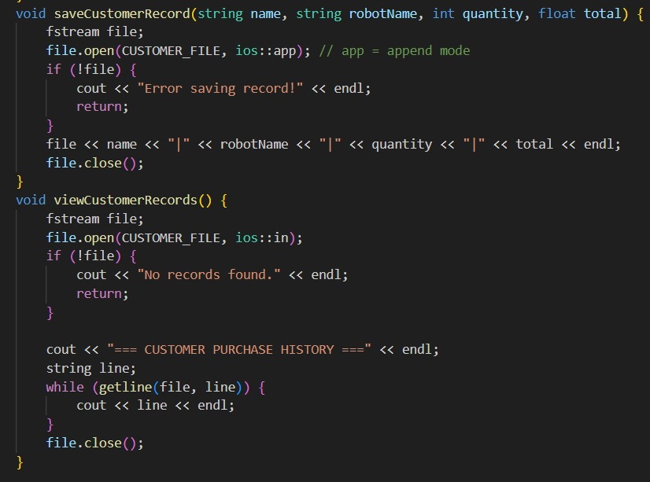
Outputs:
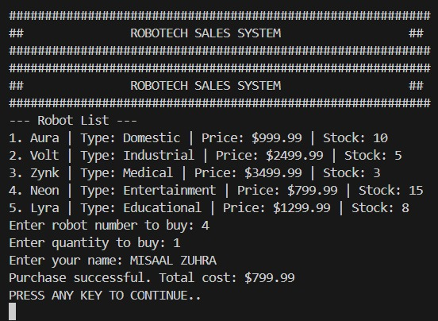

Records/Test cases:
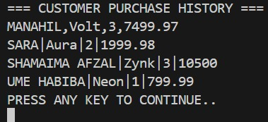

Test cases:
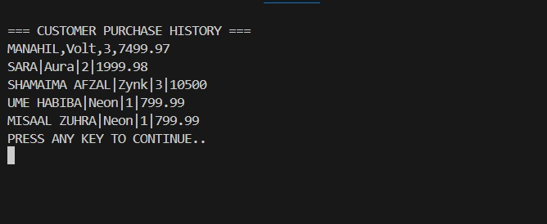

Flow chart:

The flowchart below represents the overall logic of the Robot Selling System.
It begins with user authentication, identifying whether the user is an Owner or Customer.
Based on the role, the system navigates to inventory management or robot purchasing functions.
Each operation flows through clearly defined steps for smooth execution.
This visual guide helps understand the interaction and decision-making within the program.

